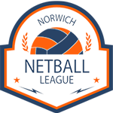

NORWICH NETBALL LEAGUE

Mid-Season Registration Form

Use this form if you register a new player after the season starts.

This must be completed and emailed to nnlresults@gmail.com BEFORE 5PM on the day of the match you wish the new player to start playing for you.

We wish to register the following player with our team:

Team Name
Name of Player
Affiliation Number
Date of Signing
Name of Previous Club

